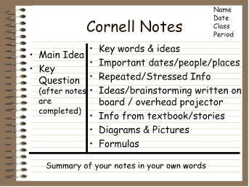

University of Mohamed KhidherBiskra

**Faculty of Arts and foreign Languages**

**Department of Foreign Languages**

**English Division**



Level: 1st year LMD Instructor: Dr. Chahira Nasri

Module: Study Skills Semester 2

**Note Taking**

Note taking is an important study skill that helps us do better.We need it to call up important information, to review information,and to store that information so we can use it later.

Definition

Note-taking is the practice of writing down or otherwise recording key points of information. It's an important part of the research process. Notes taken on class lectures or discussions may serve as study aids, while notes taken during an interview may provide material for an essay, article, or book. "Taking notes doesn't simply mean scribbling down or marking up the things that strike your fancy," say Walter Pauk and Ross J.Q. Owens in their book, "How to Study in College." "It means using a proven system and then effectively recording information before tying everything together."

**NOTE TAKING METHODS**



No matter if you are at school, at university, at work or at home taking notes is part of our daily life. Especially to understand a complex topic, it’s helpful to not just take notes but also structure them in a way so that reviewing, understanding and remembering a certain topic will be easier.

There are a number of different ways to take notes and I’d like to present the most common methods:

**1. Outline/Outlining method:**

Notes are organized in a structured form. Different topics and subtopics are organized by bullet points, dashes or numbers, that means in a form of an outline. It reduces the editing and reviewing time afterwards and the relationship between main topic and subtopics are identified quickly.

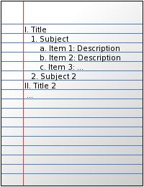

**2. Cornell method:**

Notes are structured in two columns and one row below. The smaller right column contains the notes associated with the main topic and the bigger left column contains the keywords/questions/hints associated with the notes on the right. The row below summaries the collected notes. While taking notes use the right column and reviewing your notes in the left column.

It’s a simple and efficient method to take, review and summarize your notes in a systematic format.

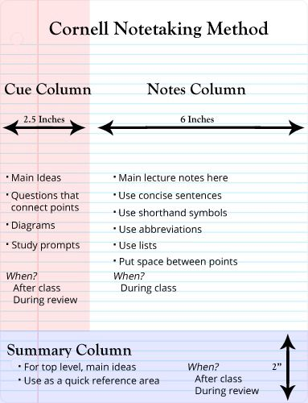

**3. Boxing method:**

All topics/pieces of information that are related to each other are grouped together in a box. The notes in each box can be organized/structured with another method like the outlining method for example.

While taking digital notes e.g. on an iPad or another tablet the boxes can be reorganised, reordered and resized really easily and quickly.

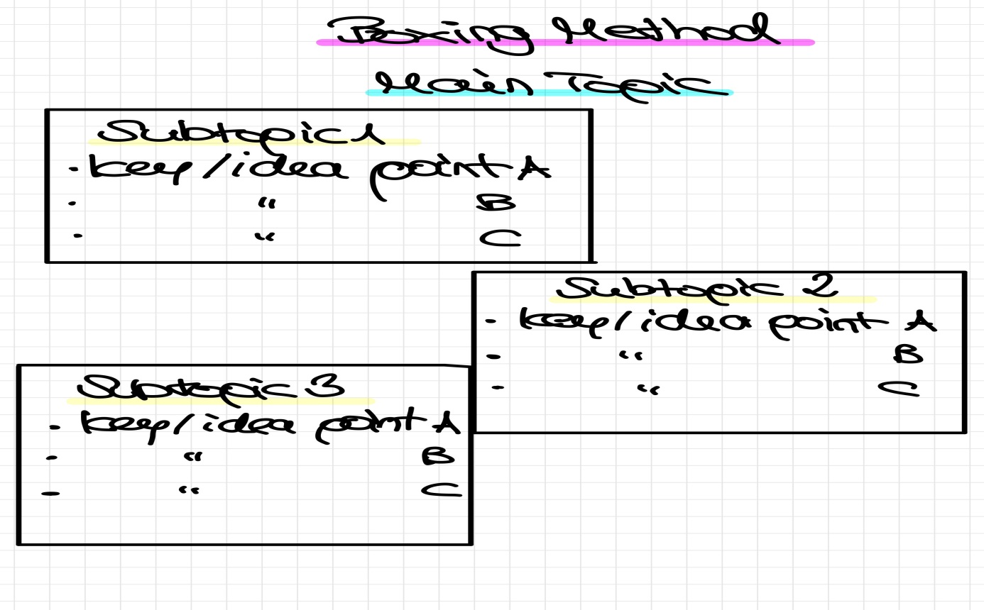

**4. Charting method:**

This method consists of a table of rows and columns. The main topic can be found in the top row and the subtopics/keywords/information are organized in the columns below. Each column categorizes a distinct topic of the main topic. It’s a useful method to get an overview over a complex topic especially when a topic covers lots of facts and statistics.

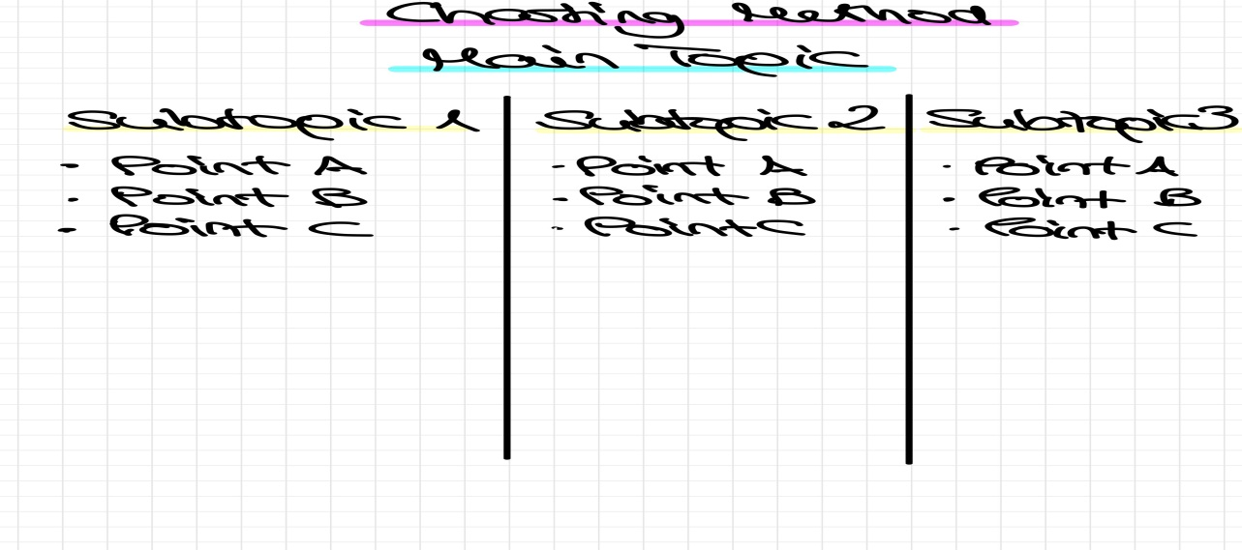

**5. Mapping method/Mind mapping:**

Notes are structured and organized in a visual way.

The main topic stands in the middle or on top of the paper. Then the main topic is divided into subtopics around/below the main topic. The subtopics are also divided into branches and can be linked with each other depending on their relationship.

Especially heavy content can be organized with this method in a simple and structured form.

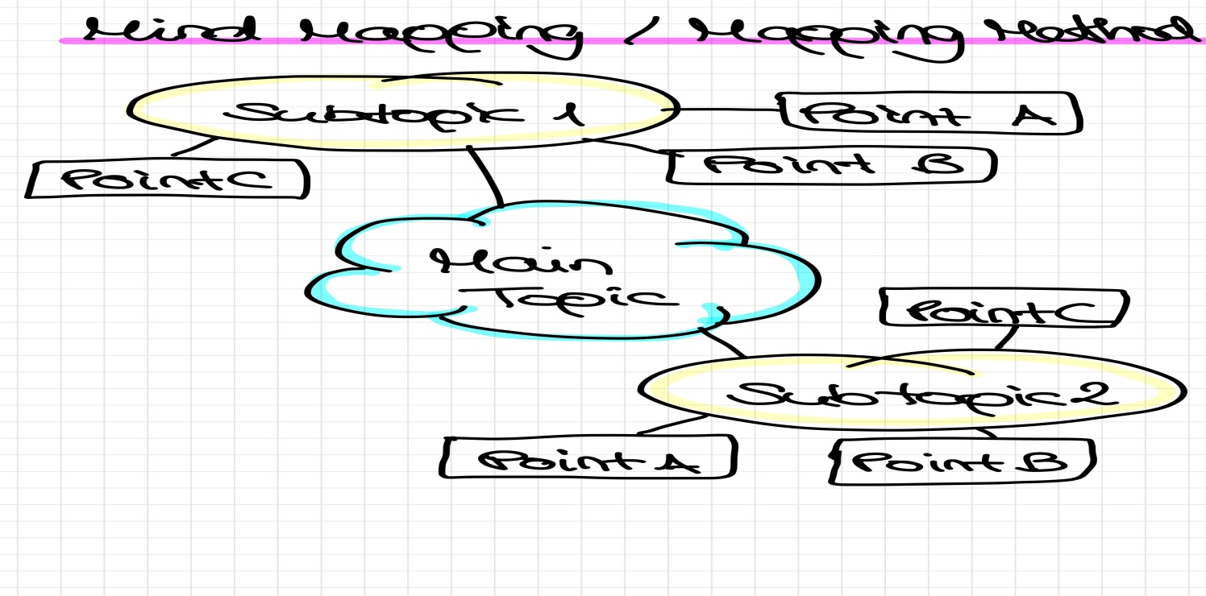

**6. Sentence method:**

Each topic is written in a whole sentence on a separate line. A visual aid, like highlighting the text with different colors, numbering each sentence and organizing main topics by using headings, can be helpful. With this method lots of details and information can be covered in a quick way.

**Benefits of effective note taking**

Despite popular opinion, note-taking has not disappeared, it has been revolutionized. For some, note-taking is an outdated concept, but its significance in learning is relentless. So why is it so important?

“Researchers found that if important information was contained in notes, it had a 34 percent chance of being remembered. Information not found in notes had only a five percent chance of being remembered” (Howe, 1970, in Longman and Atkinson, 1999).

7 Key Benefits of Effective Note-taking

It has been proven that effective note-taking enhances academic success, but does it do more?

1. Improves focus and attention to detail. Developing note-taking skills engages a student, requiring them to focus and increase their attention to detail, and as we all know, the devil is in the detail!

2. Promotes active learning. By taking effective notes, students are actively involved in the learning process thus giving it a purpose and increasing productivity.

3. Boosts comprehension and retention. A proven method of increasing memory retention, note-taking can also increase comprehension by breaking down the content for a student to consume easily.

4. Teaches prioritizing skills. Often overlooked in its importance, it is essential for a student to be able to select important material and discard unnecessary content. This further adds to their organizational and creativity skills.

5. Extends attention span. Proven to extend a student’s attention span, a necessary tool in any learning situation!

6. Improves organization skills. By prioritizing content and organizing effectively, a student develops key organization strengths. As teachers are well aware, organization is key!

7. Increases creativity. Equipped with the ability to organize their ideas effectively, focus on a particular subject and expand on ideas through knowledge retention, students can use their own initiative increasing creativity and innovation.

NOTE TAKING is a critical college success skill. The more you practice, the more proficient you will become. If you select a method and use it often, you can really improve your techniques. With good note taking techniques, you will soon be able to record the fastest instructor to your satisfaction and have a great study tool to use when preparing for your assignments and exams.

References

www.Oxford learning centres.com

http://www.uefap.net/reading/reading-note-taking/

Study Skills for Academic Writing, Phoenix 1994