**Mohamed Kheidar Biskra University - Faculty of Exact Sciences, Nature and Life**

**Department of material Sciences**

**The first semester / the scale is chemistry / Mrs. Madoui Nadia**

Rules of work and safety in the chemistry laboratory with the display of laboratory utensils

**1 Getting started with practical work**

In the field of chemistry, there are safety methods and rules that allow us to perform work in complete safety in the laboratory, allowing correct and accurate results to be obtained. In addition to these rules, a good knowledge of the equipment used in the laboratory is essential for the good progress of the work.

**2- Practical work objectives:**

🗹 Identify hazards and safety precautions in the chemical laboratory

**🗹** Learn about the most important laboratory tools and how to use them

**Security rules**

**Safety instructions to be followed in chemistry laboratories**

**🖎** Do not enter the laboratory without permission

🖎 Wear a long, buttoned cotton apron, not polyester (cotton burns if it comes into contact

with flame, as polyester melts and sticks to the skin)

🖎 Tie the hair back if it is long for the girl

🖎 Wear eye protection and gloves when handling corrosive products

🖎 Leave the corridors empty in the laboratory and movement is strictly prohibited during

practical work

🖎 Put equipment away as soon as it becomes unnecessary so that it does not get in the way.

During the next steps, also learn how to manage your work space and time

🖎 Immediately clean up any product, liquid or solid, that falls on the counter or on the floor.

🖎 Practical laboratory work must be conducted with the student standing

🖎 You must have knowledge of personal work and the work of your colleagues and be aware

of the risks it can present.

🖎 Never point a test tube at yourself or anyone else while warming or testing. Never look at

the test tube axis

🖎 All bottles without exception must have a label on which we find the name, formula, safety

chart(s).

🖎 Read the instructions for a commercial product or bottle

🖎 Any accident and any breakage or damage to the equipment must be reported immediately

to your professor

🖎 If you burn yourself or if the product gets on your skin and eyes, immediately wash the

affected area with water

🖎 Never pour water over a concentrated acid solution.

🖎At the end of the application work, empty all containers, rinse and put away the dishes, fill

the burets with distilled water and clean the work surface.

🖎 Use clean equipment in good condition

🖎 Wash your hands before and after applied work

🖎 Label vials and containers clearly

🖎 Respect the safety instructions given by the professor.

🖎 Read the safety illustrations on chemical bottles before using them

**Prohibitions**

🗹 Never eat, smoke or drink in the laboratory

🗹 Do not suck by mouth

🗹 Never inhale a chemical

🗹 Do not handle chemicals directly with your fingers or taste them

**Symbols used in chemical labels**

|  |  |  |
| --- | --- | --- |
| **Safety Instructions** | **مدلول signification** | **code**  **Pictograph** |
| Consumption, inhalation, and skin contact should be avoided by wearing gloves and a nose mask | Toxic (T)  Very toxic (T+)  Toxic and lethal to living organisms |  |
| Inhalation and skin contact should be avoided by wearing gloves and a nose mask. | ضار(Xn) noxious  مثير و مهيج Irritating (Xi)  A substance that causes irritation to the skin and eyes |  |
| It must be kept away from sources of flame. Close the bottle well and quickly after use | سريع الالتهاب fast inflammation (f)  شديد الالتهاب) (F+ Extrêmement |  |
| It must be kept away from combustible materials, used in isolation from fire and sources of electricity | محرق ) (O Oxidizer  A substance that helps with inflammation |  |
| You should avoid any contact with skin, eyes, clothing, and wear an apron and gloves. | Corrosive (C)يسبب التآكل  A caustic and burning substance that causes damage to skin and clothing |  |
| It should be used away from flames, heat sources, and avoid shocks | قابل للانفجارExplosive (E) |  |
| It must not be thrown into the sink or in the trash, but rather in special containers for that. | يلوث البيئة Pollutant (N)  A substance that pollutes the environment and poses a threat to animals and plants |  |

|  |  |  |  |  |  |  |  |
| --- | --- | --- | --- | --- | --- | --- | --- |
|  |  | |  | |  | |  |
| The graduated cylinder  L'éprouvette graduée  **مخبار مدرج** | The stemmed glass  Le verre à pied  زجاجة بقاعدة | | The Erlenmeyer flask  L'erlenmeyer  إرلينة | | the beaker  le bécher  **بيشر** | | Tube à essais  Test tube  **أنبوب إختبار** |
|  |  | |  | |  | |  |
| The glass stirrer  L'agitateur en verre  خلاط زجاجي | The volumetric flask  La fiole jaugée  حوجلة حجمية | | The volumetric pipette  La pipette jaugée  ماصة حجمية | | The graduated pipette  La pipette graduée  ماصة مدرجة | | La burette graduée  سحاحة مدرجة |
|  |  | |  | |  | |  |
| La pipette graduée  The pro-pipette  (poireaspirante)  ماصة | The watch glass  Le verre de montre  زجاجة ساعة | | L'entonnoir  The funnel  قمع زجاج | | The separating funnel  L’ampoule à décanter  قمع الفصل أوالترشيح | | Le ballon à fond rond  دورق كروي القاعدة |
|  |  | |  | |  | |  |
| pH-mètre  pH meter  PH مقياس | Balance électronique  Electronic scale  **ميزان كهربائي** | | L'agitateur magnétique  The magnetic stirrer  خلاط مغناطيسي | | The tank heater (electric)  Le chauffe ballon (électrique)  **مسخن دورق كهربائي** | | The wash bottle  La pissette  قارورة غسيل |
|  | |  | |  | |  | |
| Noix  Nut  **مثبت** | | Pince  Spoonbill  كماشة | | Bouchon  Spoonbill  غطاء فلین | | Spatule  Spoonbill  ملعقة مخبرية | |
|  | |  | |  | |  | |
| Support élévateur  Lift support  داعمة للرفع | | Valet  pregnant  حامل | | pipette automatique  automatic pipette  سحاحة أوتوماتكية | | Potence  Gallows  حاملة سحاحة | |
|  | |  | |  | |  | |
| Compte-gouttes  Dropper  قطارة | | Bec Bunsen  Bunsen burner  موقد بنزن | | Pince en bois  Wooden clamp  المشبك الخشبي | | boite de pétrie  petrie dish  علبة بتري | |
|  | |  | |  | |  | |
| Cristallisoir  Crystallizer  وعاء التبلور | | Entonnoir Büchner  Büchner funnel  قمع بوشنر | | Mortie et pilon  Mortar and pestler  مدق | | Creuset  Crucible  بوتقة | |
|  | |  | |  | |  | |
| Papier filtre  Filter paper  **ورق الترشيح** | | Réfrigérant droit  Straight refrigerant  مكثف | | Réfrigérant à boules  Ball cooler  مكثف | | Colonne de Vigreux (ou colonne à distiller)  Colone into the distiller  مكثف | |

**Safety illustrations**



**Laboratory equipment and uses**

**Measuring volumes requires high accuracy**

Conducting a chemical experiment requires the use of a number of tools (utensils and devices), some of which are used to store or carry chemicals. Measuring the volumes of liquid solutions or measuring a physical property such as weight, temperature, etc. It is necessary to know the purpose of using each of them, as well as using them correctly.

Most of the vessels used in experiments are made of glass - high-quality Pyrex glass - therefore they must be used with caution to preserve them from crushing, Because it is made of glass, it allows a good reading of the volume and monitoring of all the course of the experiment, such as a change in color, the appearance of a precipitate, or the release of gas...etc. Glassware can be divided into three categories:

**General tools**

For general use that does not require precision in measurement such as Becher, Arlene, test tube, container, etc.

**Tools included**

For precise use )requires accuracy in measuring volumes (such as a graduated tester, graduated pipette, burette, etc.

**Goji Tools**

For high precision use that requires high accuracy in volume measurement, such as Goji flask, Goji pipette, with one or two lines, etc

**Note**

The correct and accurate reading on volume measuring tools is as shown in the figure, such as a graduated tester.

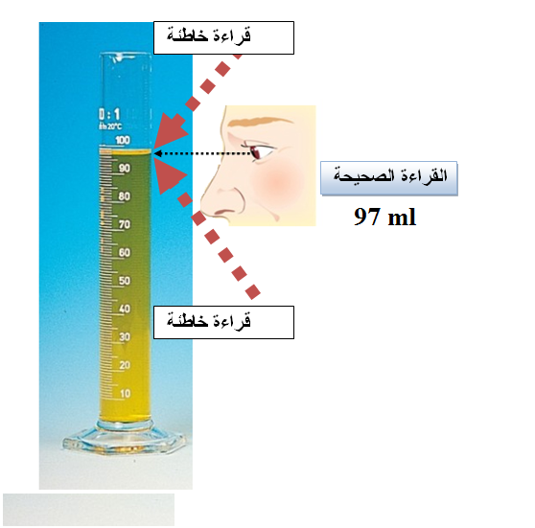

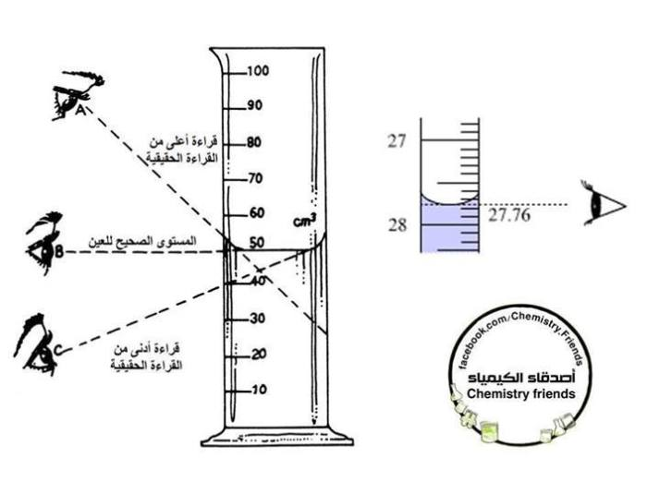

**The correct way to read a buret**

When reading the graduations in the buret, the eye of the observer must be at the level of the surface of the liquid in order to avoid a difference in reading error. Even the thickness of the lines printed on the buret plays a role in this.

**Correct reading is done**

That the bottom of the concavity of the liquid is touching the top of the line of the degree you want to measure, as in the corresponding picture in the case of transparent solutions.

In the case of highly colored solutions, where it is difficult to read at the concavity, it is read at the upper surface.

The burette must be placed vertically when reading, as the holder is placed on a flat, firm surface, and a white sheet of paper is placed behind the scale for accurate reading.