**University Mohamed Khider Biskra**

**Faculty of Science and Technology**

**Department of Civil Engineering and Hydraulics**

**Module: METAL CONSTRUCTIONS (S2) 3LMDGC**

**CHADLI MOUNIRA**

**CHAPTER 2: CALCULATION OF PARTS REQUESTED IN SIMPLE COMPRESSION**

**College year: 2023/2024**

**2.1 Definition and scope of use**

An element is said to be compressed or in pure compression when its ends are subjected to forces which impose a uniform shortening on all the fibers in any section. The result of the forces is reduced to a normal force applied to the center of gravity “G” directed towards the interior of the element. Sometimes they can be, compressed and flexed, stressed in compound flexion. In a metal frame construction we can encounter many elements which work under compression. Examples include: the compressed members of a lattice system, certain bracing bars or as secondary compressed elements (secondary post (post), brace, counter plug).

**2.2 Behavior and sizing of compressed elements**

The compressive force must Nsd must remain less than the resistant force of the section:

• For class 1, 2 and 3 sections

**Nsd ≤ Nc,Rd = Npl,Rd = Ab.Fy/ γM0**

Npl,Rd: The plastic resistance force of the cross section to compression.

Ab: The section used for class 1, 2 and 3 sections is the raw section even with the presence of bolting holes.

• For class 4 sections **Nsd ≤ Nc,Rd = Neff,Rd = Aeff. Fy/ γm1**

Neff,Rd: The resisting force of the effective section under compression.

Aeff: the effective cross-sectional area of the class 4 section.

**2.3 Simple buckling, theoretical aspect**

Most of the posts used in a metal construction have a significant slenderness (a very large height h compared to all the other dimensions of the section), which greatly influences their behavior under compression and leads to an instability phenomenon called the buckling. Buckling is the predominant and most dangerous mode of failure, it results in a sudden lateral bending of the component from a certain level of force ‘Ng’. Buckling affects simply compressed elements: simple buckling or compressed and bent elements: flexion buckling.

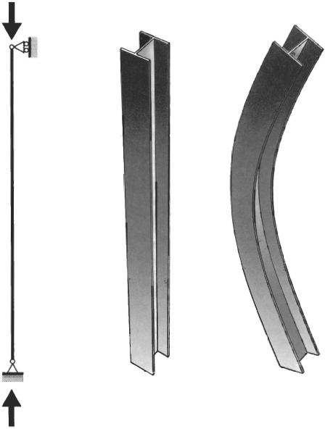

When the normal force N increases, from zero, the initial equilibrium state evolves towards a bent curvilinear state. According to the fundamental law of bending, the bending moment is written:

By asking **α =**√



we obtain the equation of elasticity

The general solution to this equation is of the form: 

* For the case of a bi-articulated beam, for example, the boundary conditions translate as follows: For z = 0, y (0) = 0 donc B = 0.
* For z = l0 , y (0) = 0 d’où A sin (α l0 ) = 0 .

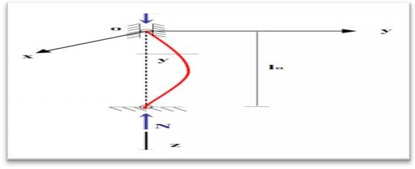

**Figure 2.2**: Bi-articulated beam subjected to a normal force

We therefore have two cases: -If : **sin (αl0) ≠0**, **A = 0** et **y (z) = 0** whatever z. in this case only rectilinear equilibrium is possible. If: sin **(α l0) = 0 , α = k π**,

##### For the beam to remain bent, K must be at least equal to 1, which leads to the minimum value of N which is:

##### The critical force of EULER .EI

Let σ k be a critical constraint corresponding to the EULER critical force N k A: being the straight section of the beam, we would have:





With: i= minimum radius of gyration corresponding to the maximum slenderness  =

 Hence finally: **k=**

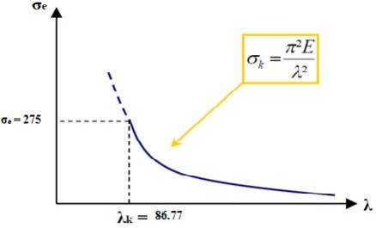

When σ k < σ e, no risk of buckling is to be feared and ruin occurs for σ = σe. • When σ k >σ e, there is failure by buckling from then on σ k = σ. Generally speaking, depending on the support conditions, the critical force of EULER is worth: lo: being the real length of the bar. 

By introducing the buckling length l k, it is written

Analogous calculations for a bi-articulated beam lead to differential equations of deformations, which are easily solved and which lead to values of m and lk summarized in this table below:

Table 2.1: Buckling lengths depending on the type of support

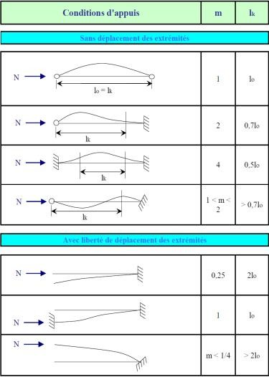

**2.4 Regulatory aspect of buckling**

EULER's theory established for ideal beams remains insufficient due to centering and straightness imperfections. It is therefore imperative to take these imperfections into account.

**2.4.1Verification according to EUROCODE 3 and CCM97**

**2.4.1.1 Simple buckling**

The risk of buckling is only considered if In this case, the simple compression stress N must satisfy

D’où  **βA=1** : for Class 1,2 or 3 cross sections.

: For class 4 cross sections

χ : Buckling coefficient for the buckling mode to be considered

For elements with constant cross section, stressed in constant axial compression, the value of χ for the reduced slenderness λ‾, can be determined by the following formula:

Hence: α: Imperfection factor



Geometric slenderness:

E

f Y

Reference slenderness:1  

235

f Y

1= 93,9                    with  

Reduced slenderness: = /1

and :  (fy : elastic limit in N/mm2)

Avec :

Ncr : is the elastic critical axial force for the appropriate buckling mode

λ : The slenderness for the buckling mode to consider The imperfection factor α corresponding to the appropriate buckling curve is:

**Table 4.2:** Value of the imperfection factor

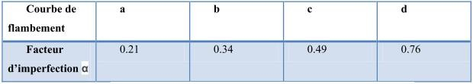

**Table 4.3**: Reduction coefficient χ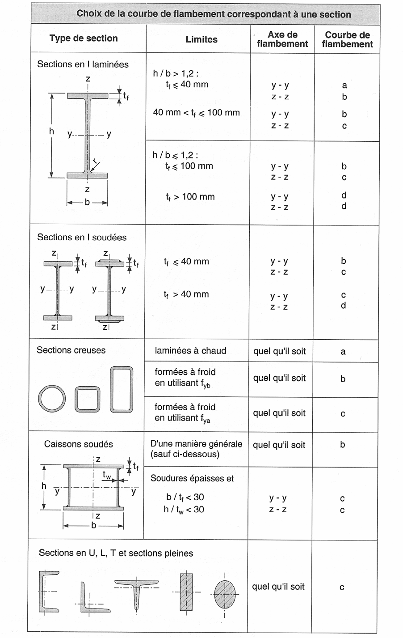



In the case of a section of a profile having two possible buckling planes, the value of χ must be determined for each of the two planes and the lowest value of two will be retained for the dimensioning of the element.

Tests carried out on real sections show that buckling generally occursθ for loads lower than the Euler critical load due to the presence of imperfections geometrical and residual stresses resulting from the manufacturing and assembly process.



**3 Sizing of solid columns subjected to simple compression according to EC3**

The modes of failure of a compressed component are:

- Complete lamination of the current section

- Local buckling of the walls of the section

- Buckling of the component

NEd ≤ Nc,Rd

1st case: 𝝀 ≤ 0.2 and cross section of class 1 or 2 or 3: there is no risk of buckling, nor risk of local buckling.

Nc,Rd = Npl,Rd = A. Fy/ γm0: plastic resistance of the raw section

2nd case: 𝝀 ≤ 0.2 and class 4 cross section: there is no risk of buckling but there is risk of local veiling Nc,Rd = Aeff. Fy/ γm1

3rd case: 𝝀 > 0.2 and cross section of class 1 or 2 or 3: there is no risk of local buckling but there is risk of buckling. .χNc,Rd = A.Fy/ γm1

4th case: 𝝀 > 0.2 and class 4 cross section: there is both a risk of buckling local and risk of buckling. .χ Nc,Rd = Aeff .Fy/ γm1