Test N°01-2
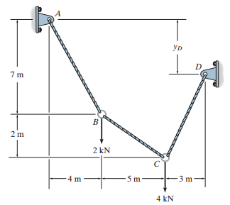
Determine the tension in each cable segment and the distance y_{D}.

Solution:

