Test N°01-2
The tied three-hinged arch is subjected to the loading shown. Determine the components of reactions A and C and the tension in the rod.
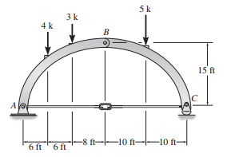
Solution:

