Test N°01-1
Draw the shear and moment diagrams for the beam. Indicate values at the supports and at the points where a change in load occurs.
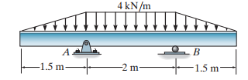
Solution:

