Language and thought

language
- a system for expressing or communicating thoughts and feelings through speech sounds or written symbols.
2. the specific communicative system used by a particular group of speakers, with its distinctive vocabulary, grammar, and phonological system.
3. any comparable nonverbal means of communication, such as sign language or the languages used in computer programming .
Language development:
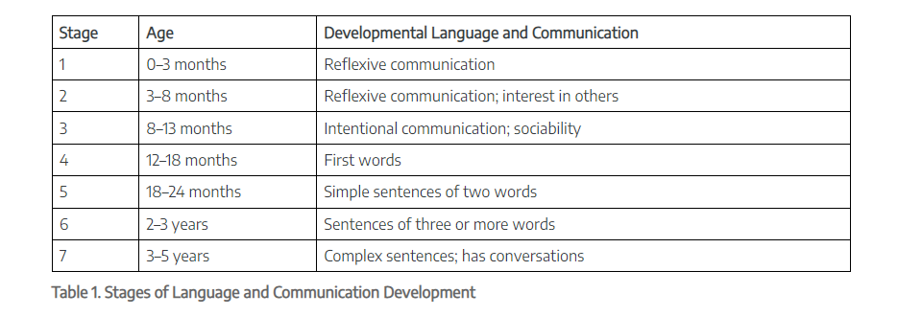

Language acquisition:
is the process by which humans acquire the capacity to perceive and comprehend language (in other words, gain the ability to be aware of language and to understand it), as well as to produce and use words and sentences to communicate.

Theories of Language acquisition:
Theory of Imitation
The basics of this theory are that children listen to verbalized communication and repeat what they hear. However, it is more complex than that. This method has been studied by many behaviorists like Pavlov (Conditioning), Skinner, and Thorndike.
Emergentism
Emergentism teaches that learning and using language come from some basic principles that are not language specific. Language seems to be a gift that is human specific. No other creature on the planet has the capability.
Chomsky believed that there was something called a separate cognitive module that made language possible and strictly a human function. The "cognitive module" theory raised some controversy in the psychological and scientific communities.
The existence of a cognitive module cannot be proven or disproven. It is theorized to be a section of the mind where thought process takes place. It may also be seen as a separate and independent section of the mind that can be utilized at certain times for other specific reasons.
Piaget studies on child development and education have been very influential in the world, today. His cognitive theory of language learning, states that learning starts with adaptation. One can achieve that adaptation through assimilation and accommodation.
Assimilation is the way that a person takes in information and makes sense of it. This can include changing the information to make it fit. Accommodation and assimilation go hand in hand. When one accommodates, he or she is using assimilation to change his or her thought patterns.
Piaget also showed that classification was also important to learning language. Certain words and sounds needed to be grouped together to better understand and use them in speech.
Classification needs to be taken a step further into sets and subsets. This can lead to a better understanding and file system for the very complex structure of language.
Empiricism
Empiricism states that learning is achieved by sensory input. Empiricism states that evidence from experiments are very important and theory, hunches, and intuition have little importance. This would be in contrast to something like Chomsky's "cognitive module".
William James used the term "radical empiricism" to describe part of his philosophy. He was adamant that structures or learning were not from any type of extra-sensory or unknown sources.
Empiricism teaches that everything has its base in the physical body and that the mind is only an invention of the brain.

Thinking
Cognitive behavior in which ideas, images, mental representations, or other hypothetical elements of thought are experienced or manipulated. In this sense, thinking includes imagining, remembering, problem solving, daydreaming, concept formation, and many other processes. Thinking may be said to have two defining characteristics: (a) It is covert—that is, it is not directly observable but must be inferred from actions or self-reports; and (b) it is symbolic—that is, it seems to involve operations on mental symbols or representations, the nature of which remains obscure and controversial .

