MOHAMED KHEIDER UNIVERSITY
FACULTY OF ECONOMICS, BUSINESS AND MANAGEMENT
DEPARTMENT OF MANAGEMENT

Lesson 03: Management Functions

According to Henry Fayol, “To manage is to forecast and plan, to organize, to command, and to control”. However, the most widely accepted are functions of management given by KOONTZ and O’DONNEL i.e. Planning, Organizing, Staffing, Directing and Controlling.

1/Planning: 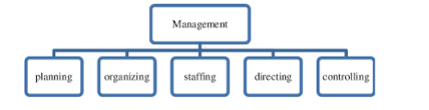
It is the basic function of management. Planning is determination of courses of action to achieve desired goals. Thus, planning is a systematic thinking about ways and means for accomplishment of predetermined goals. Planning is necessary to ensure proper utilization of human and non-human resources.
2/Organising:
It is the process of bringing together physical, financial and human resources and developing productive relationship amongst them for achievement of organizational goals. According to Henry Fayol, “To organize a business is to provide it with everything useful or its functioning i.e. raw material, tools, capital and personnel’s”. Organizing as a process involves:
• Identification of activities.
• Classification of grouping of activities.
• Assignment of duties.
3/Staffing:
According to Kootz & O’Donell, “Managerial function of staffing involves manning the organization structure through proper and effective selection; appraisal and development of personnel to fill the roles designed UN the structure”. Staffing involves:
•Recruitment, Selection and Placement.
• Training and Development.
• Performance Appraisal.

4/Directing:
It is that part of managerial function, which actuates the organizational methods to work efficiently for achievement of organizational purposes.
Direction has following elements:
• Supervision
• Motivation
• Leadership
• Communication.
5/Controlling:
According to Koontz & O’Donell “Controlling is the measurement and correction of performance activities of subordinates in order to make sure that the enterprise objectives and plans desired to obtain them as being accomplished”. Therefore controlling has following steps:
•Establishment of standard performance.
•Measurement of actual performance.
•Comparison of actual performance with the standards and finding out deviation if any.

