University Mohamed Khider Biskra
Faculty of exact sciences and natural and life sciences.
Department of Computer Science
Level : 2LMD | Date : march 2024 | Module : Operating Systems 1 | Duration : 2 sessions
PW2: Memory management by dynamic partitioning: bit map
(Session2)

We consider a memory allocation based on dynamic multiple partitions. The number of partitions (free and allocated) in this case is not constant. To maintain the state of the memory, there are several methods; the chosen method is to use the bit map (see the following figure).
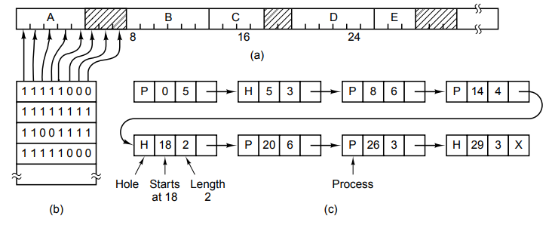
The requested work is to simulate the operation of this mode of memory management using dynamic multiple partitions, while ensuring:

Session 2:
- Calculate the rate of fragmentation in the allocation algorithm (BF).
- Simulate the task of freeing a program from a memory partition and perform the necessary update.
- Displaying the menu of choices of operations (allocation, add a new program in the queue,…) to be performed and displaying the status of the memory and the queue.
- Ensure control on inputs.
Good luck

