English lessons
Prepared by Ms. Yasmine athmani
Directed to master's students in guidance & counseling and educational psychology

Lesson one
The theory of human motivation
The theory of human motivation (Maslow, 1943), better known as Maslow's hierarchy of needs, is considered a cornerstone of understanding human motivation. Even today it continues to be used as a foundation for other theories of motivation and behavior. The theory of human motivation asserts that we each have a set of basic needs that must be met, including biological and psychological, safety, belongingness and love, self-esteem, and self-actualization. Once our basic needs are met, such as having shelter or feeling loved, we are able to focus on our higher-order needs such as self-esteem and self-actualization.
Maslow's hierarchy of needs is organized in a pyramid (see figure 3.1). The basic needs are at the base of the pyramid. As people meet their needs at each level, they are able to meet more complex needs, and they work their way closer to self-fulfillment and achieving their full potential. However, this is not a one-way process. People may find themselves revisiting levels based on life circumstances at a given time. This model provides a framework for understanding why people may be motivated toward certain behaviors at a given time; it does not provide specific steps that must be taken in order. The following sections look at each level in the hierarchy.
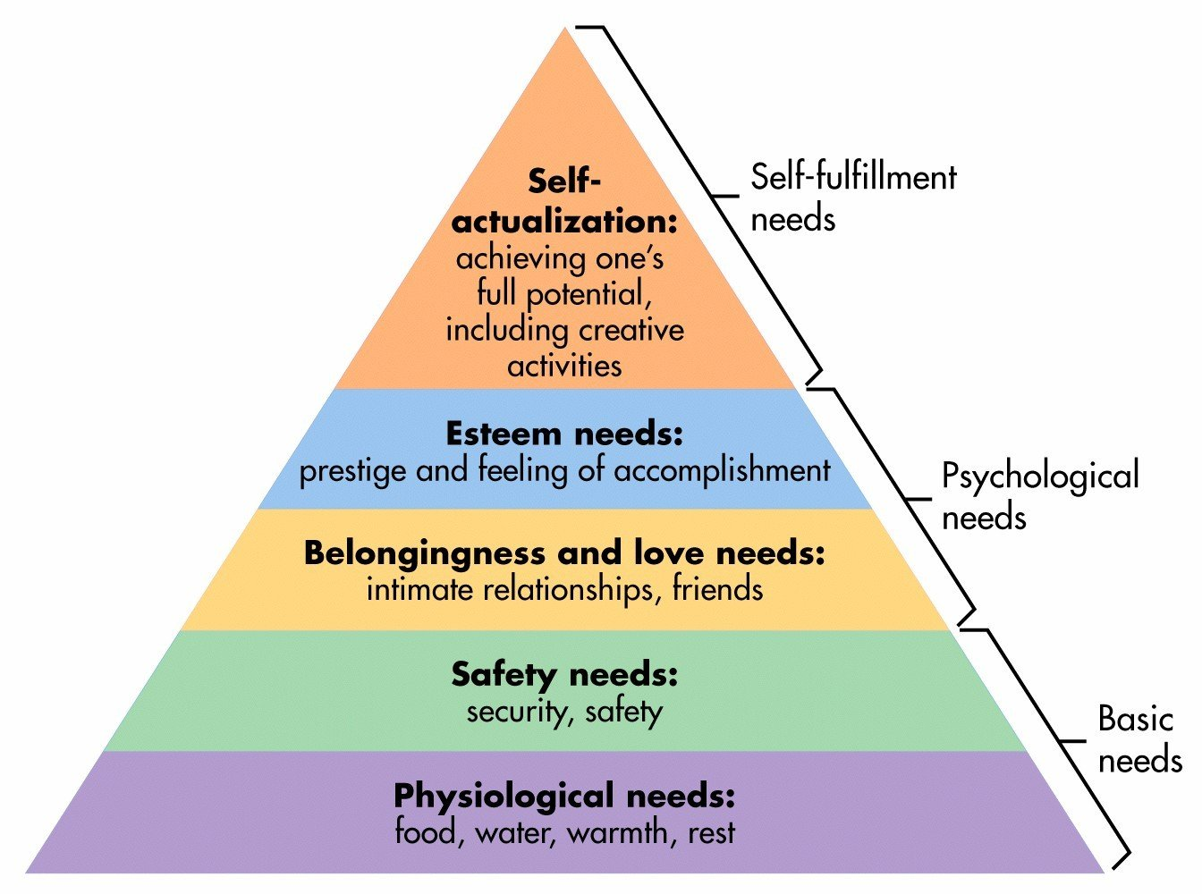
Maslow's hierarchy of needs
important terms

Need. a condition of tension in an organism resulting from deprivation of something required for survival, well-being, or personal fulfillment.

Drive. a generalized state of readiness precipitating or motivating an activity or course of action. Drive is hypothetical in nature, usually created by deprivation of a needed substance (e.g., food), the presence of negative stimuli (e.g., pain, cold), or the occurrence of negative events. Drive is said to be necessary for stimuli or events to serve as reinforcers.

satisfaction of instincts. the gratification of basic needs, such as hunger, thirst, sex, and aggression, which discharges tension, eliminates unpleasure, and restores the organism to a balanced state.

aspiration .an ambition, goal, or any kind of desired end that might be achieved through personal effort.

competition. any performance situation structured in such a way that success depends on performing better than others.

