Educational assessment

Definition:
Is the systematic process of documenting and using empirical data on the knowledge, skill, attitudes, and beliefs to refine programs and improve student learning.
Assessment data can be obtained from directly examining student work to assess the achievement of learning outcomes or can be based on data from which one can make inferences about learning. Assessment is often used interchangeably with test, but not limited to tests. Assessment can focus on the individual learner, the learning community (class, workshop, or other organized group of learners), a course, an academic program, the institution, or the educational system as a whole .
As a continuous process, assessment establishes measurable and clear student learning outcomes for learning, providing a sufficient amount of learning opportunities to achieve these outcomes, implementing a systematic way of gathering, analyzing and interpreting evidence to determine how well student learning matches expectations, and using the collected information to inform improvement in student learning .Assessment is an important aspect of educational process which determines the level of accomplishments of students.
The final purpose of assessment practices in education depends on the theoretical framework of the practitioners and researchers, their assumptions and beliefs about the nature of human mind, the origin of knowledge, and the process of learning.
Types of educational Assessment:
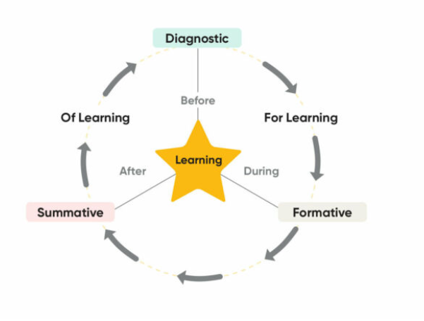
Based on what it is you need from your assessments you can build a system of assessment that typically comprises three different educational assessment types that serve different purposes depending on when they are administered: diagnostic, formative, and summative. There are other labels for assessments like pre-test, post-test, progress monitor, benchmark, or growth assessment, but those all fall into one or more of these three broad categories.

Diagnostic: When we think about educational measurements, each assessment is designed for a specific time and purpose. When an assessment happens before the learning activity, these are called diagnostic because the results can be used to diagnose problem areas to focus on during the teaching to come.
Formative: When assessment happens during the learning process, these are called formative because the results can be used to inform what to do next for individuals or groups of students as learning is occurring. Both diagnostic and formative are types of assessment for learning - meaning you are assessing to support decisions made before or during learning.
Summative: When assessments happen after the learning activity, these are called summative because the results are a summation of learning that has occurred.

