Exam
Name:………………………………  Surname:…………………………..  Group:……… | Grade: ………./20

Question N° 01: (4 points)
Complete the following table on the shape and type of each structure:
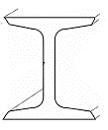
……………………… | Wide-flange beam (W-shape)
 | 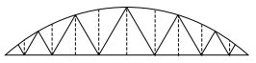
Pratt truss | ……………………..
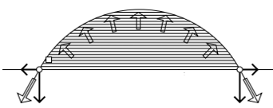
……………………… | Air-inflated structure
 | 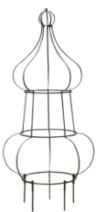
Oval dome | ………………………

Question N° 03: (03 points)
- What is the structure in the architecture?
………………………………………………………………………………………….………………………………………………………………………………………….
- What are the proposed periods of the history of long-span space structures (by the authors Dong et al, 2012) and give an example for each period?
…………………………………………………………………………………………..…………………………………………………………………………………………..…………………………………………………………………………………………..………………………………………………………………………………………….………………………………………………………………………………………….…………………………………………………………………………………………..
- What are the classifications of long-span structures? (With the explanation and give examples)
………………………………………………………………………………………….………………………………………………………………………………………….………………………………………………………………………………………….………………………………………………………………………………………….
Question N° 03: (03 points)
Fill in the blanks with the following suitable words:
Torsion, bending, shear, compression, impact, tension.
- Cables are usually flexible and carry their loads in…………….
- The arch must be rigid and achieves its strength in…………….
- The loading on a frame causes ……………. of its member.
- Howe trusses have vertical web members in …………….and diagonal web members in…………….
- The membrane is subjected to pure…………….

Exercise N° 01: (05 points)
- What is the type of the truss shown in the following figure?
- Is this truss statically determinate or indeterminate?
- Determine the force in each member at joint E, D, C, B, and A. State whether the members are in tension or compression.
The reactions at the supports are given.
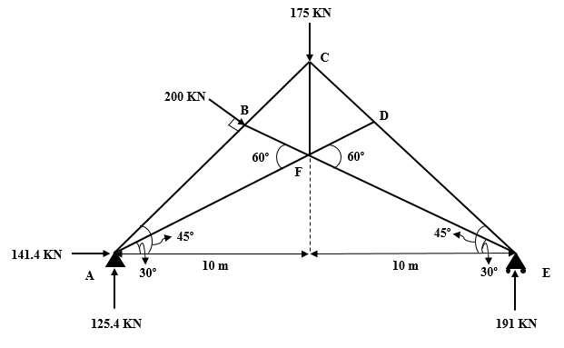

Solution:
…………………………………………………………………………………………………………………………………………………………………………………………………………………………………………………………………………………………………………………………………………………………………………………………………………………………………………………………………………………………………………………………………………………………………………………………………………………………………………………………………………………………………………………………………………………………………………………………………………………………………………………………………………………………………………………………………………………………………………………………………………………………………………………………………………………………………………………………………………………………………………………………………………………………………………………………………………………………………………………………………………………………………………………………………………………………………………………………………………………………………………………………………………………………………………………………………………………………………………………………………………………………………………………………………………………………………………………………………………………………………………………………………………………………………………………………………………………………………………………………………………………………………………………………………………………………………………………………………………………………………………………………………………………………………………………………………………………………………………………………………………………………………………………………………………………………………………………………………………………………………………………………………………………………………………………………………………………………………………
Exercise N° 02: (05 points)
The arch supports a uniform load and has the dimensions shown in the following figure, showing that the arch is subjected only to axial compression at any intermediate point such as point D. Assume the load is uniformly transmitted to the arch ribs.
- What is the type of this arch?
- Is this arch statically determinate or indeterminate?
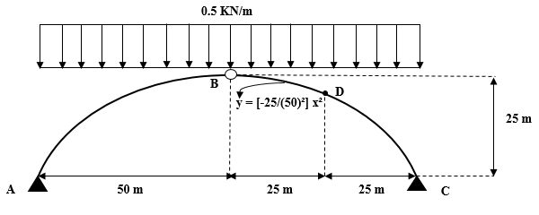
- Determine the internal forces at point D.

Solution:
…………………………………………………………………………………………………………………………………………………………………………………………………………………………………………………………………………………………………………………………………………………………………………………………………………………………………………………………………………………………………………………………………………………………………………………………………………………………………………………………………………………………………………………………………………………………………………………………………………………………………………………………………………………………………………………………………………………………………………………………………………………………………………………………………………………………………………………………………………………………………………………………………………………………………………………………………………………………………………………………………………………………………………………………………………………………………………………………………………………………………………………………………………………………………………………………………………………………………………………………………………………………………………………………………………………………………………………………………………………………………………………………………………………………………………………………………………………………………………………………………………………………………………………………………………………………………………………………………………………………………………………………………………………………………………………………………………………………………………………………………………………………………………………………………………………………………………………………………………………………………………………………………………………………………………………………………………………………………………

