Test N°01-2
Determine the force in each member of the roof truss. State if the members are in tension or compression.
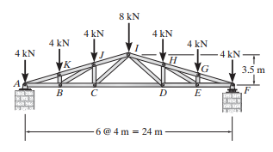
Solution:

